**[Longest Path With Different Adjacent Characters](https://leetcode.com/problems/longest-path-with-different-adjacent-characters/description/)**

You are given a **tree** (i.e. a connected, undirected graph that has no cycles) **rooted** at node 0 consisting of n nodes numbered from 0 to n - 1. The tree is represented by a **0-indexed** array parent of size n, where parent[i] is the parent of node i. Since node 0 is the root, parent[0] == -1.

You are also given a string s of length n, where s[i] is the character assigned to node i.

Return *the length of the****longest path****in the tree such that no pair of****adjacent****nodes on the path have the same character assigned to them.*

**Example 1:**

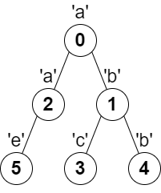

**Input:** parent = [-1,0,0,1,1,2], s = "abacbe"

**Output:** 3

**Explanation:** The longest path where each two adjacent nodes have different characters in the tree is the path: 0 -> 1 -> 3. The length of this path is 3, so 3 is returned.

It can be proven that there is no longer path that satisfies the conditions.

**Example 2:**

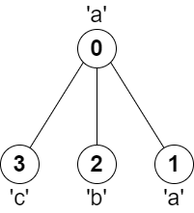

**Input:** parent = [-1,0,0,0], s = "aabc"

**Output:** 3

**Explanation:** The longest path where each two adjacent nodes have different characters is the path: 2 -> 0 -> 3. The length of this path is 3, so 3 is returned.

**Constraints:**

* n == parent.length == s.length
* 1 <= n <= 105
* 0 <= parent[i] <= n - 1 for all i >= 1
* parent[0] == -1
* parent represents a valid tree.
* s consists of only lowercase English letters.